**ECE 457**

**Fall 2019**

**Systems Requirement Review**

**ECE – 6 TV Auto Commercial Mute System**

**Report Submitted: October 1, 2019**

We, the undersigned, certify that we contributed to the generation of this report and attest to the validity of the data herein:

**Team Members:**

Steven Ferreira _____________________

Thomas Morrissey _____________________

Kevin Prairie _____________________

Zachary Taylor _____________________

**Customer:**

Dr. Paul J. Fortier

**Advisor:**

Dr. David P. Rancour

**Table of Contents**

Abstract 4

1 Introduction 4

2 System Diagrams 4

3 Customer Requirements 5

4 Engineering Requirements 6

4.1 Constraints 8

5 Standards 8

6 Initial Resource & Cost Summary 8

7 Initial Schedule 9

**List of Tables**

Table 1: Customer Requirements 5

Table 2: Customer to Engineering Requirements 5

Table 3: Resource & Cost Summary 8

**List of Figures**

Figure 1: System Data Flow Diagram 5

Figure 2: Top-Level System Diagram 5

Figure 3: System Requirements Review Schedule 10

Figure 4: Concept Design Review Schedule 11

Figure 5: Preliminary Design Review Schedule 11

Figure 6: ECE 457 Full Schedule 12

# Abstract

The TV Commercial Auto-mute system is being created to combat the initial volume spike that commercials use to quickly grab the attention of a viewer. After meeting with the customer, it was learned that the system should be able to be hidden from site, simple to set up & use, and preemptively detect the upcoming commercial break and adjust the volume accordingly. Engineering requirements have been derived from the customer’s requirements as well. At first thought, an HDMI passthrough device is the intial plan of attack, but alternatives will start to be looked at shortly. Initial system diagrams, resource summary, and schedules have been made, but are subject to change throughout the fall semester.

# Introduction

It is apparent when watching a television program that there is a spike in volume when the first commercial pops up on the screen. Based on the CALM Act, commercial breaks must not be louder than the program before or after it. Though there is a loop hole in which the average volume of the break must be no louder than its surrounding program. Thus, the initial volume spike when the break begins can be much louder than the original program, as long as the rest of the commercial brings the average back down to the base volume. This increased volume spike can catch many views offguard, startle them, and after multiple times during a single program, can become very annoying to the viewer. This project focuses on creating a system that is able to detect when a commercial is occurring and then automatically muting or lowering the volume during the duration of the commercial break.

# System Diagrams

In Figure 1, a data flow diagram is used to highlight the compenents to be used in the system as well as the flow of data between them. This diagram splits the project up into three sub sections. The first sub section is delegated for the projects Input’s and Output. The input to the HDMI pass-thru is from a TV antenna. Another box within this subsection will be a 5V DC power supply. The power supply will be 5V to match the voltage of the HDMI cable along with being the perfect amount to supply the ATMEGA328PB. The final box within this subsection is the output HDMI that will go from the pass-thru to the TV. The next subsection within this flow diagram is the signal processing sub section which is red. Within this is the signal processing tools that we are going to be using the project (ATMEGA328PB or Raspberry Pi 4). The final subsection used within this diagram is for the IR sensing/Remote controller this section is orange. Displayed in this part of the diagram is the IR sensors on both the remote and the pass-through, along with the IR receiver and transmitter. Lastly, the remote control for the system has two buttons, one for turning the system on/off while the other controls volume level.

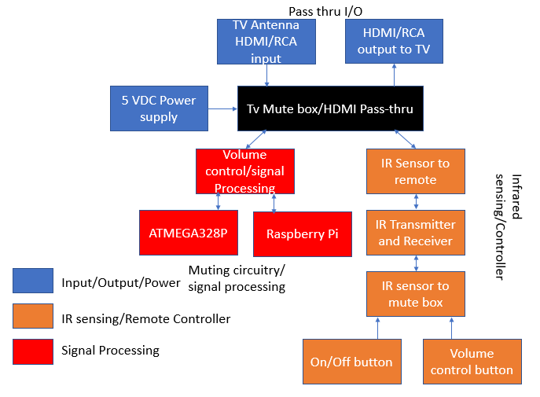

Figure 1: System Data Flow Diagram

The design displayed in Figure 2 is a top-level system design. This design gives a general external overview of the design project. It highlights where our system should connect into an existing entertainment center set-up.

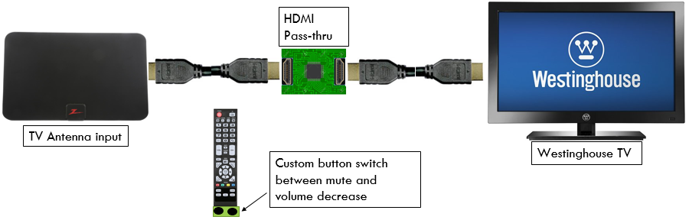

Figure 2: Top-Level System Diagram

# Customer Requirements

After meeting with our customer and asking a variety of questions based upon the research done before the meeting and the project description provided, Table 1 was created to highlight the customer’s requirements for the mute system. These requirements were generalized and were not testable in their current state, thus the set was broken down further into more detailed requirements.

Table 1: Customer Requirements

|  |  |
| --- | --- |
| Customer Requirement Number | Requirement Description |
|  | System must not obstruct the TV Screen. It must be able to be kept out of sight. |
|  | System must be able to preemptively detect a commercial break and a return to the program. |
|  | System must allow user to choose to mute completely or lower volume when a commercial is detected. |
|  | System must mute or lower volume upon break and unmute or return to original volume upon return. |
|  | System must be simple to initially set up. |
|  | System must have a user-friendly interface/remote. |
|  | System cost must be competitive with competition. |
|  | System must refrain from any alterations to the TV or its remote control. |

# Engineering Requirements

The requirements stated in Table 2 were created by breaking down the customer’s requirements into detailed, testable elements. When creating the requirements, the team assumed that the end-user knew how to use and set up a TV. For testing methods, when Table 2 states "User-Review", the team plans to give prototypes of the products to a varied age group of users and see how smoothly their experience will be. If they do not struggle with use and setup, the product will remain as is. All numerical values required in this design will be measured using Audacity, as the only output being monitored is the volume. The average decibel level will be measured in each experiment to ensure functionality.

Table 2: Customer to Engineering Requirements

|  |  |  |  |  |
| --- | --- | --- | --- | --- |
| Rqmt. # | Customer Requirement | Engineering Requirement | Justification/Comments | Test Method (IADT) |
|  | System must not obstruct the TV screen. It must be able to be kept out of sight. | System can have a cable box at most, rest of system must remain behind the TV. | The system must not be obtrusive to ensure the user has a clear and not obstructed viewing experience. | Inspection:  User-Review/Observation |
|  | System must be able to preemptively detect a commercial break and a return to the program. | System must mute to 0 dB before at least 1 millisecond before commercial break. | The system must mute preemptively in order to ensure a smoothing viewing experience for the user. | Test:  Use Audacity or other audio editing program to measure average decibel value over a time sample of 1 minute and time passed before mute was engaged. |
| 2.1 |  | System must lower volume a percentage lower before at least 1 millisecond before commercial break. | The system must abide by the user’s selection. | Test:  Use Audacity or other audio editing program to measure average decibel value over a time sample of 1 minute and time passed before mute was engaged. |
| 2.2 |  | When returning from break the TV must return to the original dB volume before the commercial break at least 1 millisecond before returning to the live show | The system shouldn’t alter the original programming at all as that is not the intent of the system and not preemptively returning the volume will result in a disturbance in the user’s experience. | Test:  Use Audacity or other audio editing program to measure exact decibel value and time passed after mute was disengaged. Measure average decibel value over a time sample of 1 minute after disengagement to ensure volume returned to original value. |
|  | System must allow user to choose to mute completely or lower volume when a commercial is detected. | The system must have a user interface that enables the user to choose between a volume of 0% (mute), 25%, 50%, 75%, 100% (off). | Giving options to the user allows for a more customizable experience. | Inspection:  Ensure quality of UI by user-review. |
|  | System must mute or lower volume upon break and unmute or return to original volume upon return. | System must lower the TV to 0 dB if that percentage is chosen. | The mute system is to ensure the user comfort by allowing the manipulation of volume. | Test:  Use Audacity to ensure the average decibel value over 3 minutes is 0 dB. |
| 4.1 |  | If lower volume is chosen the system must lower the TV’s volume by the percent chosen by the user. | Same as above. | Test:  Use Audacity to ensure the average decibel value over 3 minutes is the chosen value less than the measured programming volume. |
|  | System must be simple to initially set up. | The engineers are only to assume the users know how to: plug in an HDMI cord, | If the system is similar to design to a TV, then the user will find it easier to work with something of similar design. | Inspection/Demonstration:  User-Review/Test Subject |
| 5.1 |  | Power Cord, | Same as above. | Same as above |
| 5.2 |  | Interface with a TV remote | Same as above. | Same as above |
|  | System must have a user-friendly interface/remote. | The user interface must not consist of anything that would not already be on a TV remote or cable box. | A simple user interface allows ease-of-use and broadens the potential consumers. | Inspection/Demonstration:  User-Review/Test Subject |
|  | System cost must be competitive with competition. | The system must remain anywhere from $40 - $100 retail cost. | A low retail costs attracts more customers and makes the product more able for mass production. | Analysis:  Components and materials cost will be analyzed using Excel. The final product will be compared to competition (MuteMagic, MuTR) |
| 7.1 |  | Thus, the manufacturer cost is estimated to be between $24-$67. | A lower manufacturer costs aims for a larger profit. | Analysis:  Same as above. |
| 8. | System must refrain from any alterations to the TV or its remote control. | The TV and remote must remain the same as originally purchased. | Altering the TV or remote would require too much of the user and is not fit for mass production. | Inspection:  User-Review |

## Constraints

Included in the customer’s requirement for the auto-mute device, some constraints were brought up and needed to be addressed. The first constraint was identified to be the form factor of the mute system. The form factor of the system has to be smaller than a typical cable box. An average cable box has a height of 2.75 inches, with a width of 17.02 inches, and a depth of 10.78 inches. The mute system should fit within these dimensions. The second constraint is that the television cannot be altered or changed in any way. This includes removing or modifying parts of the TV itself or the TV remote. The third constraint includes the location of the mute system. The system should not be visible in any way. The suggested location of the system is to mount it onto the back of the television to hide the mute system entirely. The forth constraint is that there are multiple inputs included on the television. This includes HDMI and RCA connections. This constraint shows that there needs to be multiple ways of identifying visual and audio input. The fifth constraint resulted from the customer requirements is that the mute system has to be price competitive to the current competitors. Systems that have been sold include a system called MuteMagic, which sold for $39.95. Another competitor sold their product for $30 with a substription of $50 a year. The price of the mute system has to be in the same price range if not cheaper than the competition. The sixth and final constraint is the television provided by the customer that can be tested. This television is a Westinghouse HDTV. This is the TV that will be tested with the mute system. In general, this auto-mute system has six contraints brought forward from the customer requirements. Continuing on this semester, the system contraints will be modified and updated according to the tests and procedures taken throughout the semester. Some contraints may be added or removed according to the plan of action.

# Standards

1. CALM Act: Commercial Advertisement Loudness Mitigation Act:

* <https://www.provideocoalition.com/the-calm-act-commercial-advertisement-loudness-mitigation/>
* The FCC set and monitor the loudness of commercials. The ITU, International Telecommunication Union, created standard audio measurements for content that is being broadcasted

1. ITU-R BS.1170:

* <https://www.itu.int/dms_pubrec/itu-r/rec/bs/R-REC-BS.1770-4-201510-I!!PDF-E.pdf>
* Ways to measure commercial audio loudness and true-peak audio level

1. IEEE Code of Ethics

* <https://www.ieee.org/about/corporate/governance/p7-8.html>
* The responsibilities in which all engineers are expected to follow that are expressed in a code of ethics.

1. Betamax Case: Sony Corp. of America v. Universal City Studios, Inc.

* <https://www.oyez.org/cases/1982/81-1687>
* Ruled recording TV legal

1. Copyright Laws and Television:

* <https://yourbusiness.azcentral.com/copyright-laws-television-16286.html>
* TV cable programs have copyrights to a program that can be violated (file sharing and sales, dependent on each program)

# Initial Resource & Cost Summary

Table 3 summarizes the initial resource list needed by the team to begin prototyping, developing alternatives, and working towards a solution to the problem. Resources listed with a cost of N/A have either an unknown cost at this time, or are readily available with no purchase necessary. This table will be updated as new equipment is needed or prices change on existing resources. If a different and more optimal approach is decided upon during the Concept Design Review phase of the semester, the resource table will change accordingly to fit the needs of the new plan of attack.

Table 3: Resource & Cost Summary

|  |  |
| --- | --- |
| Resource | Cost |
| Custom PCB | N/ |
| ATMega328PB chip | $1.26 |
| Raspberry Pi 4 | $35.00 |
| 5V DC Power supply | $9.00 |
| IR Transmitter & Receiver | $6.98 |
| Westinghouse HDTV & Remote | N/A |
| PCB Fabricator | N/A |
| TV Antenna | $21.98 |
| HDMI Cable | $6.99 |
| 3D Printer | N/A |
| Eagle Schematic & PCB Design | N/A |
| Atmel Studio 7.0 | N/A |
| Audacity | N/A |
| Total | $81.21 |

# Initial Schedule

Figures 3-5 provide an initial schedule for each progress report for the semester. Within the bar for each task includes the initials of the team member(s) responsible for the task, along with the number of hours assumed to take to complete the task. Markers are used to signify the three major due dates for the semester. As the semester progresses, these schedules will be updated to account for any impedances or breakthroughs the team runs into. Members responsible, new tasks, and hours to complete are all subject to change as we move forward through the semester.

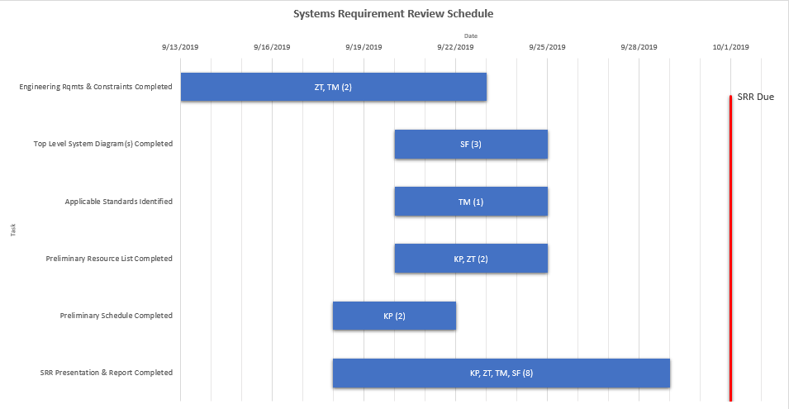

Figure 3: System Requirements Review Schedule

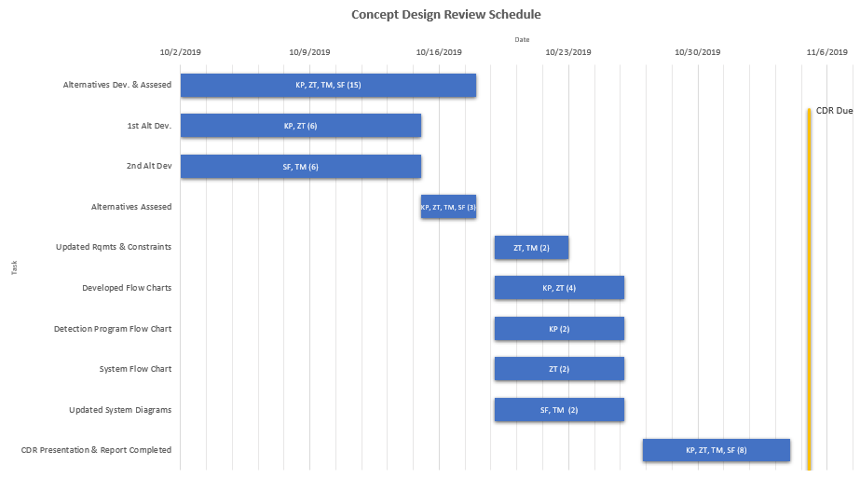

Figure 4: Concept Design Review Schedule

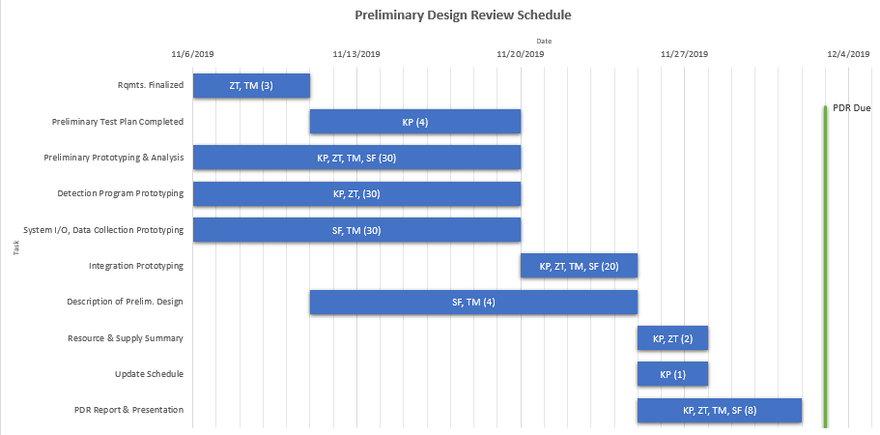

Figure 5: Preliminary Design Review Schedule

Figure 6 combines the three schedules into an overall plan for ECE 457. The team feels as though it is best to make a plan that does not include work over the winter break because the likelihood of major tasks getting done while on break is low. Rather, based upon this schedule, any work done during the break would be seen as a bonus rather than a requirement. During the semester the team plans to meet weekly on Fridays at 10:00 AM. Advisor meetings with Dr. Rancour will also occur weekly on Wednesdays at 10:00 AM. If members are not able to attend, available members will still meet and discuss the progress made within the week and plan for the following week.

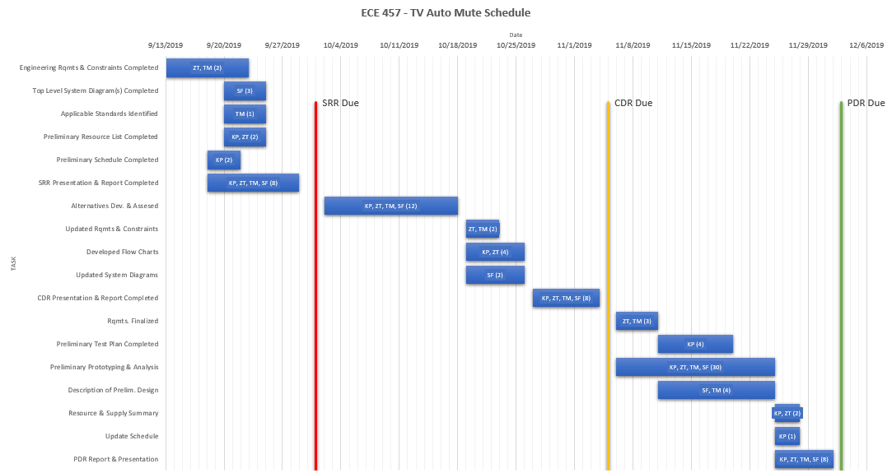**Figure 6: ECE 457 Full Schedule**